
In 2026, the United States will commemorate the 250th anniversary of the signing of the Declaration of Independence and the founding of the country. It is an opportunity for reflection on the ideals of the nation's founders and a time to consider the path forward in expanding our realization of those ideals today.
AMERICA 250 | CT EDUCATOR RESOURCES
3RD GRADE

COMMISSION MEMBERS

Hon. Denise W. Merrill
Chair

Jason R. Mancini, Ph.D.
Vice Chair

Nicolas Angeli
Connecticut’s Old State House – Youth Leader

Stephen Armstrong
Connecticut State Dept. of Education

Michael Johnson
Mashantucket Pequot Tribal Nation Designee

Anthony Champalimaud
Member of the Public

Tom Scanlon
Governor’s Designee

Melvette Hill
Commission on Women, Children, Seniors, Equity & Opportunity

Andrew Horowitz, Ph.D.
State Historian

Robert Kret
Connecticut Museum of Culture & History

Catherine Labadia
State Historic Preservation Office Designee

Margaret Khan
Connecticut Library Association

Merle McGee
Member of the Public

Deborah Schander, MLIS, JD
State Librarian

Elizabeth Shapiro
Dept. of Economic & Community Development Designee

Jonathan Slifka
Dept. of Aging & Disability Services

Joe Smith
Mohegan Tribe Designee

Stephanie Thomas
Secretary of the State

Maisa Tisdale
Mary & Eliza Freeman Center for History & Community

Sally Whipple
Connecticut Democracy Center

Amrys O. Williams, Ph.D.
Connecticut League of Museums

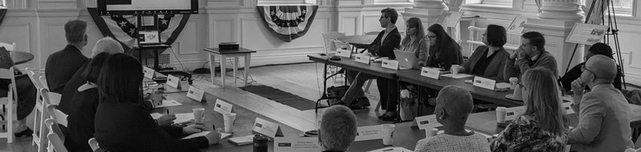

USING THIS PACKET

As the nation prepares to commemorate the 250th anniversary of the signing of the Declaration of Independence and the founding of the country, this educator’s packet encourages K-12 students to reflect on the ideals of the nation's founders and consider how those ideals have evolved over time. Supporting a reawakening of civic engagement, this packet touches on the following America 250 | CT themes, specifically within the context of Connecticut and the American Revolution:

- Power of Place
  - Grade 3 - Our Town’s Story: “What Makes Our Town Special?”
- Tell Inclusive Stories*
  - Grade 5 - Hannah Bunce Watson: “Whose Story Gets Told?”
- Doing History*
  - Grade 8 - Benedict Arnold and Abigail Hinman: “Sources and Stories”
- For the Common Good*
  - High School - Lemuel Haynes: “Freedom and Liberty in 1776”

All lessons align with the 2022 Connecticut Elementary and Secondary Social Studies Standards. While lessons have been designed to speak to certain grade levels and learning goals, any lesson can be modified to suit any grade. Please feel free to adapt these lessons and activities as you see fit for your classroom.


This packet is shared under Creative Commons Attribution-ShareAlike 4.0 International License, supporting open access to learning materials.

EDUCATORS AND LEARNERS: You may use, share, print, and modify this content freely. Please credit CT Humanities and maintain this open license.

*For other grade level lessons, see full packet.

POWER OF PLACE

This theme highlights the unique identities and contributions of Connecticut's diverse communities. Educators can explore how specific towns, cities, and geographical features in Connecticut played a role in the Revolution, or focus on the impact of place more broadly. Connecticut is made up of 169 towns and cities, five recognized tribes, and countless communities. Every place in our state is home to someone and has its own unique history, traditions, and contributions—together, they make up Connecticut.

Questions to Consider:

- What makes your community unique?

- How have communities changed across Connecticut?

- Why are particular historic places preserved and valued?

GRADE 3 LESSON
Our Town’s Story: “What Makes Our Town Special?”

- Educator Guide
  - Time Allotment
  - Learning Objectives
  - Standards
  - Materials
  - Step-by-Step Procedure
  - Opportunities for Assessment
- Printables and Worksheets
  - Postage Stamp Template

OUR TOWN’S STORY
What Makes Our Town Special?

Educator Guide

Grade Level: 3rd Grade
Time Allotment: 1-2 class periods (adaptable)

Learning Objectives:
- Students will learn to develop compelling and supporting questions about what makes their town or city special.
- Students will gather relevant information about their local history from multiple sources, such as maps, historical images, and potentially resources from local museums, historical societies, or historic sites. They will use evidence from these sources to develop claims in response to their questions about their town's history.

Standards:
- 3.Geo.2.a. Use maps and other visual representations to describe the relationship between the locations of places and regions throughout Connecticut and their environmental characteristics (e.g., access to natural resources, education, labor, population, transportation).
- 3.Geo.6.a. Describe how environmental and cultural characteristics influence where people live and work in Connecticut (e.g., rivers, parks, farmland, location of ethnic communities, transportation, urban development).

Materials:
- A whiteboard or chart paper to keep track of student responses.

OUR TOWN’S STORY
What Makes Our Town Special?

Procedure:

- Engage (20 minutes):
- Assign students into small groups of 3-4 to “turn and talk” about the following questions:
  - When you think of a town or city, what comes to mind?
  - What kinds of buildings (e.g., post office, library, town hall) can you find in a town or city?
  - What has to be considered when a town or city is created?
  - Who makes decisions about how towns develop, grow, or change?
  - What makes one town or city different from another town or city?
- Allow groups time to talk about questions and then share their responses as a whole group.

- Focus on a Specific Site (10 minutes):
- Focus on a specific local landmark or site (e.g., a historic building, a local museum, a town green, a place significant to a local cultural community) in your town that is accessible or about which resources are available.
- As a class or in small groups, guide students to develop compelling questions about this place, such as: "What makes [Local Landmark Name] special to our town?" or "How has this place shaped our community over time?" Share these on the whiteboard.
- Then, help students formulate supporting questions that will help answer the compelling question, like "Who used this place in the past?", "What important events happened here?", or "How is this place used by people today?". Discuss where they might find information to answer these questions, considering different perspectives (e.g., library, town hall, historical society/museum, newspapers, books, interviewing a neighbor or town official, etc.).
OUR TOWN’S STORY
What Makes Our Town Special?

Opportunities for Assessment:

Students can share what they learned through the following activities:

Landmark Postage Stamp
Students can design a postage stamp featuring an important local landmark (they may select the landmark discussed as a class or identify their own). A template is included on page 9. Draw the landmark in the center of a stamp outline, including the name of the town and a pretend stamp value (e.g., “5¢”). Below the stamp, write 2–3 sentences explaining what the landmark is and why it is important to the town.

Town Map
Students can create a simplified map of their town that highlights 3–5 important places from its past or present. Using their imaginations based on experience or providing an existing town map as a guide, have them draw a large map showing key sites (schools, parks, historical sites, etc.). They can label each location with small illustrations or symbols and write short captions or fun facts next to each place to explain its importance.

“History in a Bag”
Students can gather 3–5 small objects (or pictures of objects) that represent their town’s history or identity (e.g., a pinecone for a local forest preserve, a photo of a train for a historic railway). Place the selected items in a paper bag or small box. One by one, take each item out to show the class and explain its importance.
OUR TOWN’S STORY
Worksheet: Landmark Postage Stamp

Design Your Own Postage Stamp!

Choose an important local landmark and draw it below. Include the name of your town and a pretend stamp value (like “5¢”).

What is this landmark? Why is it important to your town?

EXTENSION ACTIVITES
for Teaching “Power of Place”

Teach It Lessons

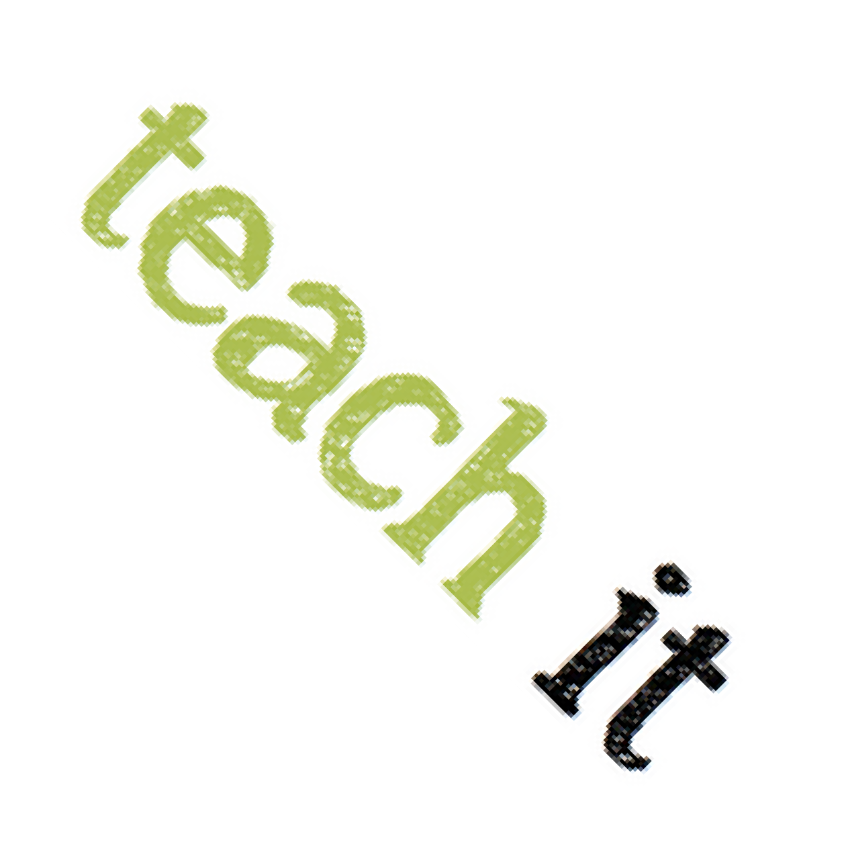
- Learn about Abigail Hinman and New London’s Role in American Independence with a Teach It activity for grades 5 and 8.
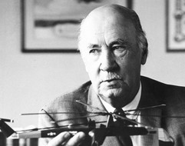
- Explore William Lanson’s New Haven through the activities “Nearly Forgotten: Re- discovering a New Haven Activist, Engineer, and Entrepreneur” (Grade 4) and “William Lanson: New Haven Entrepreneur, Abolitionist, and Black Governor” (Grade 8).

People

- Frederick Law Olmsted, Hartford
- Igor Sikorsky, Stratford
- Hannah Ocuish, New London
Igor Sikorsky

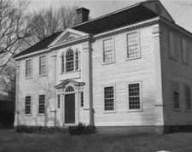
Places

- Fort Griswold, Groton
- Mashantucket
- Prudence Crandall House, Canterbury

Events
Prudence Crandall House

- British burn Danbury - April 26, 1777
- British burn Fairfield - July 7, 1779
- Washington & Rochambeau meet in
Wethersfield - May 21-22, 1781

EDUCATIONAL RESOURCES
RESOURCES

Teach It provides inquiry-based activities that reinforce the principles found in the state social studies standards to help Connecticut’s teachers bring Connecticut history into the classroom.

ConnecticutHistory.org is a state public history resource that provides engaging, well-researched stories about Connecticut history that link to reliable primary and interpretive resources.

The Connecticut Council for the Social Studies will be hosting conferences for students and teachers focused on the themes of the 250th.

Teachers and students are encouraged to participate in Connecticut History Day and develop projects related to the 250th and the themes for this commemoration.

Connecticut’s Kid Governor immerses 5th graders in a real election for the CT Kid Governor, a fellow 5th grader who will represent them during a one-year term of active leadership. The program teaches about state government, voting, elections, and civic participation.

The Museum of the American Revolution has put together a Summer Reading List for young readers, covering books appropriate for ages 7-14.


ONLINE RESOURCES

Connecticut Archives Online (CAO) brings together information about primary source collections from over 50 institutions in CT into one site. CAO can connect you with unique archival material and where you can go to find it.

Connecticut Collections (CTCo) makes resources from over 50 museums and archives throughout the state accessible in one place. CTCo is a resource for teachers, students and researchers to learn discover collections, find local history, and learn about art.

The Connecticut Digital Archive (CTDA) is a digital repository of over 3+ million digital objects. CTDA facilitates access to a wide range of resources from over 100 Connecticut organizations.

Connecticut Explored is the nonprofit magazine of Connecticut history. Anyone with an interest in the untold stories of Connecticut’s past can satisfy their curiosity with each issue of Connecticut Explored. The magazine offers a variety and range of stories that connect our past to our present and future.

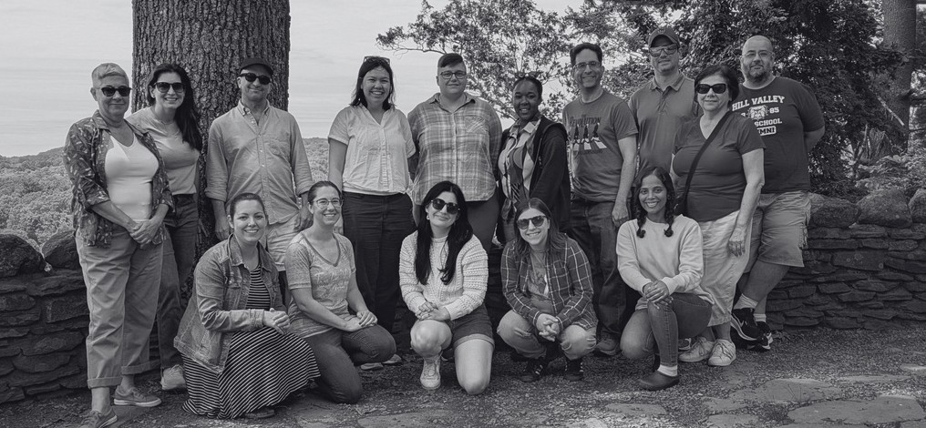



CT Humanities (CTH) is the non-profit organization recognized by the State of Connecticut to coordinate and lead the plans for commemorative, educational, and civics-based initiatives leading up to and during 2026.CTH will serve as the administrative agent and act as the nonprofit fiduciary on behalf of any activities undertaken by the America 250 | CT Commission.

As the principal grantmaking organization for history, cultural, and civics organizations in Connecticut, CTH will bring together communities and cultural resources throughout our state and lead the sector in developing a meaningful commemoration.

ABOUT THE COMMISSION

In order to recognize this moment in our history, Governor Ned Lamont established the America 250 | CT Commission with Executive Order 22-2.

Mission:

To plan and coordinate activities commemorating the 250th anniversary of the nation’s founding; and enhance tourism, economic development, historic education and preservation, and outdoor recreation within the state; and coordinate, engage, and liaise with the U.S. Semiquincentennial Commission, and other local, county, and state commissions, as well as private and public organizations and partners. The Commission will develop, encourage, and execute an inclusive celebration, commemoration, and observance of the 250th anniversary of the Declaration of Independence through civic, cultural, and historical education events and programming; and will promote the documentation, identification, and preservation of cultural and historic resources, including archives, buildings, landscapes, objects, and sites related to the semiquincentennial period.

To learn more about the America 250 | CT Commission, including existing resources, upcoming meetings, and ways to get involved, visit CT250.org.

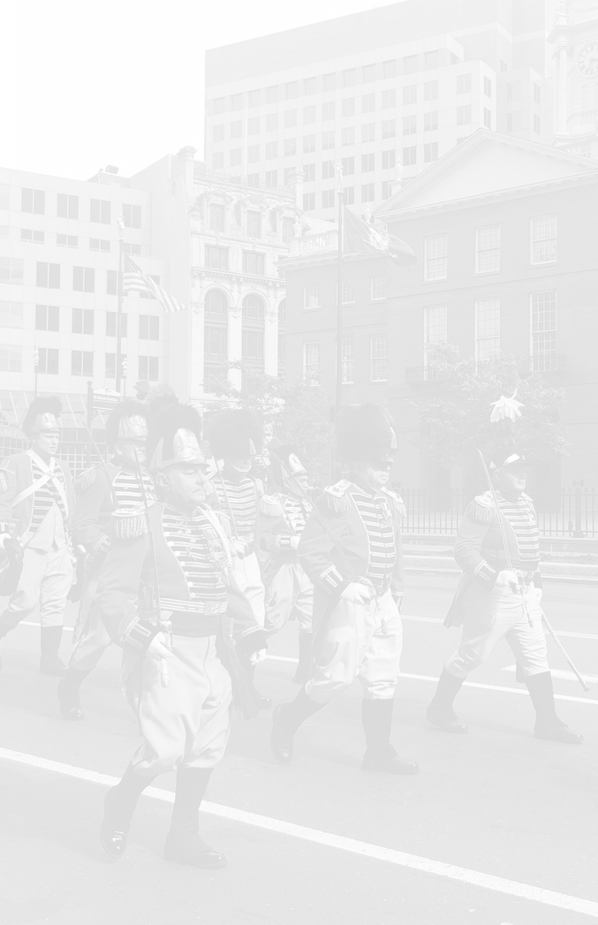



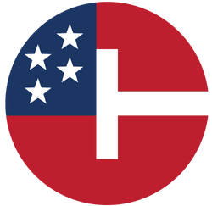
STAY
CONNECTED

info@CT250.org

www.CT250.org

