
In 2026, the United States will commemorate the 250th anniversary of the signing of the Declaration of Independence and the founding of the country. It is an opportunity for reflection on the ideals of the nation's founders and a time to consider the path forward in expanding our realization of those ideals today.
AMERICA 250 | CT EDUCATOR RESOURCES
HIGH SCHOOL

COMMISSION MEMBERS

Hon. Denise W. Merrill
Chair

Jason R. Mancini, Ph.D.
Vice Chair

Nicolas Angeli
Connecticut’s Old State House – Youth Leader

Stephen Armstrong
Connecticut State Dept. of Education

Michael Johnson
Mashantucket Pequot Tribal Nation Designee

Anthony Champalimaud
Member of the Public

Tom Scanlon
Governor’s Designee

Melvette Hill
Commission on Women, Children, Seniors, Equity & Opportunity

Andrew Horowitz, Ph.D.
State Historian

Robert Kret
Connecticut Museum of Culture & History

Catherine Labadia
State Historic Preservation Office Designee

Margaret Khan
Connecticut Library Association

Merle McGee
Member of the Public

Deborah Schander, MLIS, JD
State Librarian

Elizabeth Shapiro
Dept. of Economic & Community Development Designee

Jonathan Slifka
Dept. of Aging & Disability Services

Joe Smith
Mohegan Tribe Designee

Stephanie Thomas
Secretary of the State

Maisa Tisdale
Mary & Eliza Freeman Center for History & Community

Sally Whipple
Connecticut Democracy Center

Amrys O. Williams, Ph.D.
Connecticut League of Museums



USING THIS PACKET

As the nation prepares to commemorate the 250th anniversary of the signing of the Declaration of Independence and the founding of the country, this educator’s packet encourages K-12 students to reflect on the ideals of the nation's founders and consider how those ideals have evolved over time. Supporting a reawakening of civic engagement, this packet touches on the following America 250 | CT themes, specifically within the context of Connecticut and the American Revolution:

- Power of Place
  - Grade 3 - Our Town’s Story: “What Makes Our Town Special?”
- Tell Inclusive Stories*
  - Grade 5 - Hannah Bunce Watson: “Whose Story Gets Told?”
- Doing History*
  - Grade 8 - Benedict Arnold and Abigail Hinman: “Sources and Stories”
- For the Common Good*
  - High School - Lemuel Haynes: “Freedom and Liberty in 1776”

All lessons align with the 2022 Connecticut Elementary and Secondary Social Studies Standards. While lessons have been designed to speak to certain grade levels and learning goals, any lesson can be modified to suit any grade. Please feel free to adapt these lessons and activities as you see fit for your classroom.


This packet is shared under Creative Commons Attribution-ShareAlike 4.0 International License, supporting open access to learning materials.

EDUCATORS AND LEARNERS: You may use, share, print, and modify this content freely. Please credit CT Humanities and maintain this open license.

*For other grade level lessons, see full packet.

FOR THE COMMON GOOD

This theme invites a reconsideration of the origins of American government, democratic institutions, and civic life as they relate to the Revolutionary period in Connecticut. Discussions can center on the democratic ideals outlined in the founding documents and how Connecticut citizens engaged with or were impacted by these ideals during the Revolution.

Questions to Consider:

- How did the ideas of the American Revolution influence the development of civic life in Connecticut?

- How can understanding the origins of our government inform civic engagement today?

- What did “freedom” mean at the time of the American Revolution? Does it hold the same meaning today?

HIGH SCHOOL LESSON
Lemuel Haynes: “Freedom and Liberty in 1776”

- Educator Guide
  - Time Allotment
  - Learning Objectives
  - Standards
  - Materials
  - Step-by-Step Procedure
  - Opportunities for Assessment
  - Images and Additional Resources
- Printables and Worksheets
  - Excerpt from “Liberty Further Extended: Or Free Thoughts on the Illegality of Slave-keeping”
  - Source Analysis Worksheet
  - “Freedom-seeker Advertisement: Jude”
  - “Liberty triumphant” Cartoon
  - “The Horse America throwing his master” Cartoon

LEMUEL HAYNES
Freedom and Liberty in 1776

Educator Guide

Grade Level: High School
Time Allotment: 2-3 class periods (adaptable)

Learning Objectives:
- Students will analyze the foundational ideals of freedom and liberty articulated in 1776 by examining diverse perspectives, such as those presented in the Declaration of Independence and by Lemuel Haynes, in order to understand the complex origins of American democratic ideals and their influence on civic life.
- Students will assess how the competing interpretations of freedom and liberty in 1776 highlight enduring issues in American history related to justice, equality, and representation.

Standards:
- US.Inq.1.a. Explain how compelling and supporting questions reflect an enduring issue in United States History.
- US.Inq.1.b. Explain how supporting questions contribute to an inquiry and how new compelling and supporting questions emerge when engaging sources that represent varied perspectives.
- CG.Civ.5.a. Evaluate the relationship between law-making, enforcement, and interpretation in balancing the rights of the individual with the well being of society (e.g., Bill of Rights, Supreme Court cases.

Materials:
- Printed or digital copies of The Declaration of Independence and “Liberty Further Extended: Or Free Thoughts on the Illegality of Slave- keeping” to distribute to students
- Whiteboard, chart paper, or digital tool for recording student ideas
- Source Analysis Worksheet
- Students will need paper and a writing utensil or a computer to complete the Opportunities for Assessment
LEMUEL HAYNES
Freedom and Liberty in 1776

Procedure:

- Teacher Preparation (5 minutes):
- Lemuel Haynes is widely considered to be the first Black man in America to be ordained by a Protestant church. Born in West Hartford in 1753 to a Black father and a white mother, he went to live with Deacon David Rose and his family in Granville, Massachusetts where he was an indentured servant until 1774. In 1776, at the age of 23, he wrote an unfinished, unpublished essay entitled, “Liberty Further Extended: Or Free Thoughts on the Illegality of Slave- keeping,” in which he explored the ideals of freedom and liberty, as referenced in the Declaration of Independence, and related them to enslaved people. Haynes’ manuscript illustrates that antislavery rhetoric far pre-dates the better-known abolitionist movement of the 1830s. The concept that freedom and liberty are God-given natural rights and that governments can and should be held accountable for protecting those rights was applied by Haynes to enslaved Black people just as it was to American colonists by the writers and signers of the Declaration of Independence. In this activity, students will examine and compare the language and ideas behind these two powerful documents.
- Decide whether you want all of the students to look at both documents or break the class into 2 groups: one to examine the Declaration of Independence and the other to examine the excerpt from “Liberty Further Extended.”

- Annotations (20 minutes):
- Introduce the compelling question: “What did ‘freedom’ mean at the time of the American Revolution?” Explain that students will be exploring this question through a close reading of two documents written in 1776.
  - Have students read and annotate the documents. What words or phrases stand out as most important in defining freedom? In students’ own words, what are the documents saying?”
LEMUEL HAYNES
Freedom and Liberty in 1776

- Focused Analysis (30 minutes):
- Next, move on to the supporting questions and some more focused analysis:
  - What freedoms did the colonists who wrote and signed the Declaration of Independence claim as their rights in the preamble?
  - In what ways did these colonists feel oppressed or not free?
  - What were three grievances or complaints they had regarding freedom and liberty?
  - What did the colonists claim was a reasonable response to having their freedom or liberty curtailed?
  - What do you think Lemuel Haynes meant by his title, “Liberty Further Extended”?
  - What arguments did Lemuel Haynes make on behalf of enslaved people? What grievances or complaints did he articulate?
  - What persuasive language did the colonists and Haynes use? To what extent do you think Haynes was influenced by the Declaration of Independence? Point to evidence in the texts.
  - How did the differing definitions and experiences of “freedom” and “liberty” in 1776 illuminate tensions in the concept of "the common good" for the emerging United States?

- Final Discussion (10 minutes):
- Revisit the compelling question and discuss the types of actions that were taken by these two groups at the time (discontented colonists and enslaved people) in response to the infringement on their freedom and liberties.
  - These might include joining a militia or enlisting in the Continental army (which could also be a path to freedom for enslaved people), escaping enslavement, working as a spy or passing information, working to purchase one’s freedom, petitioning the government, protesting, or speaking or writing about the cause of freedom and liberty.
LEMUEL HAYNES
Freedom and Liberty in 1776

- Opportunities for Assessment:
- Option 1: Students will select one of the following primary sources and analyze it using the Source Analysis Worksheet. (For an additional activity about primary and secondary sources, see page 29). Then they will write a short essay explaining how this new source relates to the Declaration of Independence and/or “Liberty Further Extended.”
  - “Freedom-seeker Advertisement: Jude.” Connecticut Courant, August 9, 1774.
  - “Liberty triumphant; or the downfall of oppression.” c. 1774.
  - Library of Congress Prints and Photographs Division, Washington, D.C.
  - “The Horse America throwing his master.” Published by William White, Westminster, August 1, 1779. Library of Congress Prints and Photographs Division, Washington, D.C.

- Option 2: Students can respond to one of the following writing prompts:
  - Often enslaved people have not been part of the story of the American Revolution. How do the words and actions of African Americans in the Revolutionary period help define who we are as Americans?
  - Describe a recent event in your school, town, state, or nation in which people raised concerns or took actions related to the “unalienable rights” described in the Declaration of Independence.
“LIBERTY FURTHER EXTENDED…”
Transcription

Transcription:

We hold these truths to be Self-Evident, that all men are created Equal, that they are endowed by their Creator with certain unalienable rights, that among these are Life, Liberty, and the pursuit of happiness.

Congress.

[...] Liberty, & freedom, is an innate principle, which is unmovably placed in the human species; and to see a man aspire after it, is not enigmatical, seeing he acts no ways incompatible with his own nature; consequently, he that would infringe upon a man’s liberty may reasonably expect to meet with opposition, seeing the defendant cannot comply to non-resistance, unless he counteracts the very laws of nature.

Liberty is a jewel which was handed down to man from the cabinet of Heaven, and is coeval with his existence. And as it proceeds from the Supreme Legislature of the universe, so it is He which hath a sole right to take away; therefore, he that would take away a mans Liberty assumes a prerogative that belongs to another, and acts out of his own domain.

One man may boast a superiority above another in point of Natural privilege; yet if he can produce no convincive arguments in vindication of this preeminence his hypothesis is to be suspected. To affirm, that an Englishman has a right to his Liberty, is a truth which has been so clearly evinced, especially of late, that to spend time in illustrating this, would be but superfluous tautology. But I query, whether Liberty is so contracted a principle as to be confined to any nation under Heaven; nay, I think it not hyperbolical to affirm, that even an African, has equally as good a right to his Liberty in common with Englishmen. [...] (cont’d)

“LIBERTY FURTHER EXTENDED…”
Transcription

Transcription, cont’d:

‘It hath pleased God to make of one Blood all nations of men, for to dwell upon the face of the Earth.’ Acts 17, 26–23. And as all are of one species, so there are the same laws, and aspiring principles placed in all nations; and the effect that these laws will produce, are similar to each other. Consequently we may suppose, that what is precious to one man, is precious to another, and what is irksome, or intolerable to one man, is so to another, considered in a law of nature. Therefore we may reasonably conclude, that Liberty is equally as precious to a Black man, as it is to a white one, and Bondage equally as intolerable to the one as it is to the other: Seeing it effects the laws of nature equally as much in the one as it does in the other. But, as I observed before, those privileges that are granted to us by the Divine Being, no one has the least right to take them from us without our consent; and there is not the least precept, or practice, in the sacred scriptures, that constitutes a Black man a Slave, any more than a white one.

Shall a mans color be the decisive criterion whereby to judge of his natural right? Or because a man is not of the same color with his neighbour, shall he be deprived of those things that distinguisheth him from the beasts of the field? [...]

LEMUEL HAYNES
Source Analysis

Structure: What kind of source is it - primary or secondary? Is it a formal government paper, a personal diary entry, a newspaper article, a map, a photograph, or a painting? The type of source affects what kind of information it gives you and how you should use it.

Origin: Where did this source come from? Who made it? When and where was it made? Was it created during the time period you're studying or much, much later? Knowing the origin is the first step to trusting a source. What was happening in the world when the source was made?

Purpose: What was the creator’s purpose? Was Arnold required to take the oath? Was the painter trying to celebrate a local hero?
Understanding the situation and the creator's goals helps you understand the source.

Point of View: Was the person or group who made this source in a position to really know what happened? Were they there? Were they involved, or just observing? Were they an official record-keeper? What sort of bias might the creator have? Who is the author’s intended audience, and how might they affect the reliability of the source?

Corroboration: Does this source agree with or back up what other reliable sources say? Historians look for multiple sources that tell the same story. If you find the same detail in several different, trustworthy places, it corroborates that detail. If a dramatic detail only appears in one later source, it has less corroborative value.

Credibility: Finally, after considering all the above: How believable or trustworthy is this source overall? Some sources are highly credible for certain facts, while others might be less credible or only useful for understanding beliefs or legends from the time.

Source:

Structure
Origin
Purpose
Point of View
Corroboration
Credibility

LEMUEL HAYNES
Worksheet: Source Analysis
“FREEDOM-SEEKER ADVERTISEMENT: JUDE”
Connecticut Courant, August 9, 1774

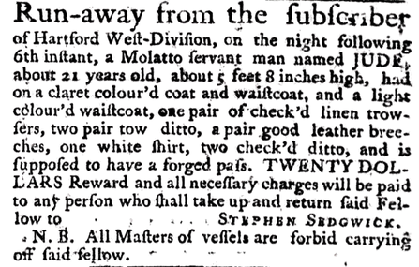

Transcription:

Run-away from the subscriber of Hartford West-Division, on the night following 6th instant, a Molatto servant man named JUDE, about 21 years old, about 5 feet 8 inches high, had on a claret colour’d coat and waistcoat, and a light colour’d waistcoat, one pair of check’d linen trowsers, two pair tow ditto, a pair good leather breeches, one white shirt, two check’d ditto, and is supposed to have a forged pass. TWENTY DOLLARS Reward and all necessary charges will be paid to any person who shall take up and return said Fellow to ... STEPHEN SEDGWICK.

N.B. All Masters of vessels are forbid carrying off said fellow.

Freedom-seeker Advertisement: Jude. Connecticut Courant, August 9, 1774.

“LIBERTY TRIUMPHANT; OR THE DOWNFALL OF OPPRESSION”
Henry Dawkins, Engraver

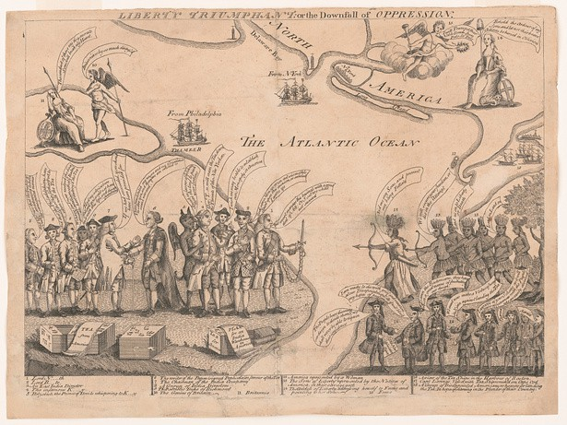

“Liberty triumphant; or the downfall of oppression.” c. 1774. Library of Congress Prints and Photographs Division, Washington, D.C.

“THE HORSE AMERICA, THROWING HIS MASTER”
Published by Wm. White

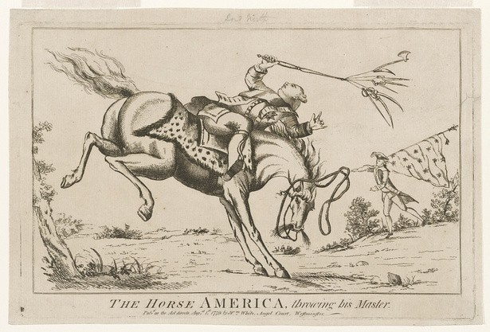

“The Horse America throwing his master.” Published by William White, Westminster, August 1, 1779. Library of Congress Prints and Photographs Division Washington, D.C.

LEMUEL HAYNES
Images, Additional Resources

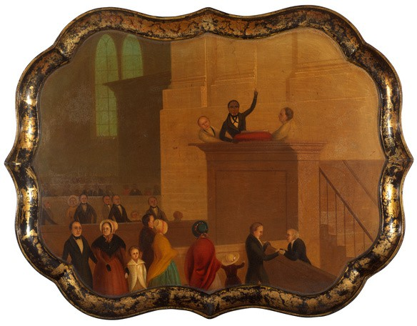
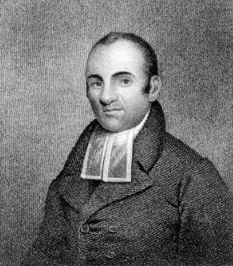
Lemuel Haynes from Sketches of the Life and Character of the Rev. Lemuel Haynes, A.M. by Timothy Mather Cooley, 1837, Wikimedia Commons. Used through Public Domain
Tray Depicting Reverend Lemuel Haynes, ca. 1835-1840. Courtesy of the RISD Museum, Providence, RI. Used through Public Domain.
Additional Resources:

Lemuel Haynes: America’s First Black Ordained Minister

Teaching American History: Liberty Further Extended

The Founding Project: Lemuel Haynes’ Liberty Further Extended

EXTENSION ACTIVITES
for Teaching “For the Common Good”

Teach It Lessons


- Teach students about government in the Connecticut Colony with a Teach It activity for Grade 5: "The Fundamental Orders: Rules and Laws for Early Colonial Connecticut."
- Help students understand the history of housing segregation in Connecticut with a High School lesson about Sheff v. O’Neill.

People

- Thomas J. Dodd, state senator
- Constance Baker Motley, federal judge
- Maria Colón Sánchez, activist
Litchfield Law School

Places

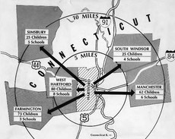
- Mashantucket Pequot Museum & Research Center, Mashantucket
- Old State House, Hartford
- Litchfield Law School, Litchfield

Events
Map of school bussing (Sheff v. O’Neill)

- CT General Assembly Approves the Declaration of Independence -
October 10, 1776
- Mohegan Tribe granted federal
recognition - May 15, 1994

EDUCATIONAL RESOURCES
RESOURCES

Teach It provides inquiry-based activities that reinforce the principles found in the state social studies standards to help Connecticut’s teachers bring Connecticut history into the classroom.

ConnecticutHistory.org is a state public history resource that provides engaging, well-researched stories about Connecticut history that link to reliable primary and interpretive resources.

The Connecticut Council for the Social Studies will be hosting conferences for students and teachers focused on the themes of the 250th.

Teachers and students are encouraged to participate in Connecticut History Day and develop projects related to the 250th and the themes for this commemoration.

Connecticut’s Kid Governor immerses 5th graders in a real election for the CT Kid Governor, a fellow 5th grader who will represent them during a one-year term of active leadership. The program teaches about state government, voting, elections, and civic participation.

The Museum of the American Revolution has put together a Summer Reading List for young readers, covering books appropriate for ages 7-14.


ONLINE RESOURCES

Connecticut Archives Online (CAO) brings together information about primary source collections from over 50 institutions in CT into one site. CAO can connect you with unique archival material and where you can go to find it.

Connecticut Collections (CTCo) makes resources from over 50 museums and archives throughout the state accessible in one place. CTCo is a resource for teachers, students and researchers to learn discover collections, find local history, and learn about art.

The Connecticut Digital Archive (CTDA) is a digital repository of over 3+ million digital objects. CTDA facilitates access to a wide range of resources from over 100 Connecticut organizations.

Connecticut Explored is the nonprofit magazine of Connecticut history. Anyone with an interest in the untold stories of Connecticut’s past can satisfy their curiosity with each issue of Connecticut Explored. The magazine offers a variety and range of stories that connect our past to our present and future.





CT Humanities (CTH) is the non-profit organization recognized by the State of Connecticut to coordinate and lead the plans for commemorative, educational, and civics-based initiatives leading up to and during 2026.CTH will serve as the administrative agent and act as the nonprofit fiduciary on behalf of any activities undertaken by the America 250 | CT Commission.

As the principal grantmaking organization for history, cultural, and civics organizations in Connecticut, CTH will bring together communities and cultural resources throughout our state and lead the sector in developing a meaningful commemoration.

ABOUT THE COMMISSION

In order to recognize this moment in our history, Governor Ned Lamont established the America 250 | CT Commission with Executive Order 22-2.

Mission:

To plan and coordinate activities commemorating the 250th anniversary of the nation’s founding; and enhance tourism, economic development, historic education and preservation, and outdoor recreation within the state; and coordinate, engage, and liaise with the U.S. Semiquincentennial Commission, and other local, county, and state commissions, as well as private and public organizations and partners. The Commission will develop, encourage, and execute an inclusive celebration, commemoration, and observance of the 250th anniversary of the Declaration of Independence through civic, cultural, and historical education events and programming; and will promote the documentation, identification, and preservation of cultural and historic resources, including archives, buildings, landscapes, objects, and sites related to the semiquincentennial period.

To learn more about the America 250 | CT Commission, including existing resources, upcoming meetings, and ways to get involved, visit CT250.org.






STAY
CONNECTED

info@CT250.org

www.CT250.org

