
In 2026, the United States will commemorate the 250th anniversary of the signing of the Declaration of Independence and the founding of the country. It is an opportunity for reflection on the ideals of the nation's founders and a time to consider the path forward in expanding our realization of those ideals today.
AMERICA 250 | CT EDUCATOR RESOURCES
5TH GRADE

COMMISSION MEMBERS

Hon. Denise W. Merrill
Chair

Jason R. Mancini, Ph.D.
Vice Chair

Nicolas Angeli
Connecticut’s Old State House – Youth Leader

Stephen Armstrong
Connecticut State Dept. of Education

Michael Johnson
Mashantucket Pequot Tribal Nation Designee

Anthony Champalimaud
Member of the Public

Tom Scanlon
Governor’s Designee

Melvette Hill
Commission on Women, Children, Seniors, Equity & Opportunity

Andrew Horowitz, Ph.D.
State Historian

Robert Kret
Connecticut Museum of Culture & History

Catherine Labadia
State Historic Preservation Office Designee

Margaret Khan
Connecticut Library Association

Merle McGee
Member of the Public

Deborah Schander, MLIS, JD
State Librarian

Elizabeth Shapiro
Dept. of Economic & Community Development Designee

Jonathan Slifka
Dept. of Aging & Disability Services

Joe Smith
Mohegan Tribe Designee

Stephanie Thomas
Secretary of the State

Maisa Tisdale
Mary & Eliza Freeman Center for History & Community

Sally Whipple
Connecticut Democracy Center

Amrys O. Williams, Ph.D.
Connecticut League of Museums



USING THIS PACKET

As the nation prepares to commemorate the 250th anniversary of the signing of the Declaration of Independence and the founding of the country, this educator’s packet encourages K-12 students to reflect on the ideals of the nation's founders and consider how those ideals have evolved over time. Supporting a reawakening of civic engagement, this packet touches on the following America 250 | CT themes, specifically within the context of Connecticut and the American Revolution:

- Power of Place
  - Grade 3 - Our Town’s Story: “What Makes Our Town Special?”
- Tell Inclusive Stories*
  - Grade 5 - Hannah Bunce Watson: “Whose Story Gets Told?”
- Doing History*
  - Grade 8 - Benedict Arnold and Abigail Hinman: “Sources and Stories”
- For the Common Good*
  - High School - Lemuel Haynes: “Freedom and Liberty in 1776”

All lessons align with the 2022 Connecticut Elementary and Secondary Social Studies Standards. While lessons have been designed to speak to certain grade levels and learning goals, any lesson can be modified to suit any grade. Please feel free to adapt these lessons and activities as you see fit for your classroom.


This packet is shared under Creative Commons Attribution-ShareAlike 4.0 International License, supporting open access to learning materials.

EDUCATORS AND LEARNERS: You may use, share, print, and modify this content freely. Please credit CT Humanities and maintain this open license.

*For other grade level lessons, see full packet.

TELL INCLUSIVE STORIES

This section encourages educators and students to delve into stories that represent all the people of Connecticut during the Revolutionary era, both past and present. By exploring previously untold stories of Connecticut residents during this time, we can enable everyone to find a place in our nation's narrative.

Questions to Consider:

- Whose voices from Connecticut during the Revolution have been traditionally heard, and whose have been marginalized?

- How can we uncover and share a more complete picture of this period?

- What stories remain untold in your community? Whose voice has been heard in the past? How is this celebration an opportunity to lift other voices?

GRADE 5 LESSON
Hannah Bunce Watson: “Whose Story Gets Told?”

- Educator Guide
  - Time Allotment
  - Learning Objectives
  - Standards
  - Materials
  - Step-by-Step Procedure
  - Opportunities for Assessment
  - Images and Additional Resources
- Printables and Worksheets
  - Hannah’s Story, Vocabulary
  - Fill in the Blank, Multiple Choice
  - Short-Answer Questions
  - Hannah’s Story (for Advanced Readers)

HANNAH BUNCE WATSON
Whose Story Gets Told?

Educator Guide

Grade Level: 5th Grade
Time Allotment: 1-2 class periods (adaptable)

Learning Objectives:
- Students will be able to identify key facts about Hannah Bunce Watson and her role as publisher of the Connecticut Courant during the American Revolution.
- Students will understand that telling "inclusive stories" means sharing the experiences and contributions of all people, including those who may have been previously excluded from the main historical narrative.
- Students will be able to construct a brief narrative or "Hall of Fame" entry for Hannah Bunce Watson that includes her significant contributions as a publisher, demonstrating an understanding of telling a more inclusive story.

Standards:
- 5.His.6.a. Describe how people’s perspectives of the American Revolution are documented in historical records while noting representation of marginalized voices (e.g., journals, letters, newspaper articles, pamphlets).
- 5.His.16.c. Develop a claim about significant people, places or events in Connecticut during the American Revolution (e.g., Jonathan Occum, Israel Putnam, Hannah Bunce Watson, Benedict Arnold, Jordan Freeman).

Materials:
- Student-friendly summary of Hannah Bunce Watson’s story. There is a version on page 19 for more advanced readers.
- Students will need paper and a writing utensil or a computer to complete the Opportunities for Assessment.
HANNAH BUNCE WATSON
Whose Story Gets Told?

Procedure:

- Engage (20 minutes):
- Introduce Hannah Bunce Watson as a remarkable woman from the time of the American Revolution in Connecticut. Explain that she ran a newspaper called the Connecticut Courant, which was important for sharing news about the war, and an uncommon role for women at the time.
- Read Hannah’s story (page 16) aloud or have students read independently. (There is a version on page 19 for more advanced readers.)
- Ask students about the challenges she faced. Emphasize that despite this, she kept the newspaper going and used it to support the idea of American liberty.

- Comparing Narratives (10 minutes):
- Share with the students how Hannah was remembered right after she died. Read her obituary: “Died in this city, on Sunday last, Mrs. Hannah Hudson, wife of Mr. Barzillai Hudson, senior editor of this paper, aged 58 years.”
  - Ask students: "Does this short description tell the whole story of Hannah? What’s missing?”
  - Note that it calls her "Mrs. Hannah Hudson, wife of Mr. Barzillai Hudson" and doesn't mention her work running the newspaper or helping the Revolution.
- Explain that sometimes, important parts of people's lives, especially for groups like women, were left out of the historical record or not seen as important at the time. Then, share that much later, organizations like the Connecticut Women's Hall of Fame did recognize her as one of America's first female publishers.
  - Ask students: "Why do you think these groups decided to tell her story differently?" Connect this to the idea of telling inclusive stories – stories that make sure everyone's contributions, even those previously overlooked, are known.
HANNAH BUNCE WATSON
Whose Story Gets Told?

Opportunities for Assessment:

Students can share what they learned through the following activities:

“Hall of Fame” Entry
Have the students imagine they are creating a "Young Historians Hall of Fame" for people from the American Revolution. Their task is to write a short entry for Hannah Bunce Watson that makes sure her important work as a publisher and her challenges are included, reflecting the idea of telling a more complete or "inclusive" story. How would their entry be different from her original obituary? What details would they highlight to show her unique contribution?

Research
Students can explore the stories of different women (Mary Ludwig Hays, Phillis Wheatley, Deborah Samson, or others) or members of underrepresented groups during the American Revolution. What other stories should be told?

Students looking for more of a challenge can learn more about Hannah through Hannah’s Story for Advanced Readers (page 12) to complete either of the following activities.

Newspaper
Students can design the front page of a Connecticut Courant issue that Hannah Bunce Watson might have printed during the Revolution. What sort of articles would it feature?

Timeline
Students can design a timeline of Hannah Bunce Watson’s life and accomplishments, highlighting key events such as when she took over the newspaper, major challenges, and her contributions. This could be presented as a physical or digital display.
HANNAH BUNCE WATSON
Images, Additional Resources

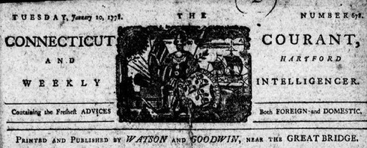
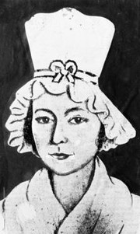
The Connecticut Courant and Hartford Weekly Intelligencer header under Hannah Bunce Watson, January 20, 1778.
When her husband Ebenezer died, Hannah Bunce Watson took over the Courant, becoming one of the first women publishers in the country – Hartford Courant file photo
Additional Resources:

Hannah Bunce Watson: One of America’s First Female Publishers

Connecticut Women’s Hall of Fame

The First Lady of Connecticut Newspapers

Litchfield Historical Society: Hannah Bunce Hudson
HANNAH BUNCE WATSON
Hannah’s Story, Vocabulary

Hannah’s Story:

Hannah Bunce Watson was the publisher of the Connecticut Courant (now called the Hartford Courant) between 1777 and 1779. As a widow, Watson inherited the Connecticut Courant from her late husband, Ebenezer, becoming one of the first women publishers in the country, and operated it until she married Barzillai Hudson in 1779. She used the paper to spread news on the American Revolution across the 13 colonies, while possessing little business experience, being a mother of five, and overcoming a devastating fire at the company’s paper mill that threatened to close down her entire operation. Hannah Watson’s articles called for support of the patriot cause and defiantly aided her country’s search for liberty, earning her a place in the Connecticut Journalism Hall of Fame and the Connecticut Women’s Hall of Fame.

Vocabulary:

publisher (noun): a person or company that prepares, prints, and issues books, newspapers, or other materials for sale.
Example: The publisher helped the author get her book ready to sell.

paper mill (noun): a factory that makes paper from wood or recycled materials.
Example: The paper mill is a noisy place because of all the machines.

patriot (noun) someone who loves and strongly supports their country.
Example: The patriot waved the flag proudly during the parade.

defiantly (adverb): in a way that shows you are refusing to obey.
Example: The child defiantly refused to eat their vegetables.

liberty (noun): the freedom to do what you want without being
controlled by someone else.
Example: The bird flew out of its cage and enjoyed its liberty.
HANNAH BUNCE WATSON
Worksheet: Fill in the Blank, Multiple Choice

Fill in the blank with the correct words:
Word Bank: publisher, paper mill, patriot, defiantly, liberty

- Hannah Bunce Watson took over the Connecticut Courant as the after her husband died.
- Hannah is recognized as a today.
- One big challenge Hannah faced was when the burned down.
- Hannah showed her bravery by writing articles during the American Revolution.
- Hannah supported the patriot soldiers’ fight for freedom and .

Choose the correct answer from the choices:
1. What is the Connecticut Courant now known as?
a. The Hartford Courant
b. The Connecticut Times
c. The Boston Globe
d. It is still known as the Connecticut Courant
2. Who did the newspaper mainly support during Hannah's leadership?
a. The loyalists
b. The British king
c. The patriots
d. The French army
3. What happened to the newspaper's paper mill?
a. It moved to a new city
b. It was sold
c. It burned down
d. It was never used
4. Why is Hannah Bunce Watson remembered today?
a. She wrote famous books
b. She started a school
c. She kept the newspaper running and supported the patriots
d. She was a famous artist
HANNAH BUNCE WATSON
Worksheet: Short Answer Questions

- Hannah Watson faced many challenges but kept working hard. What is a time you faced a challenge, and how did you keep going?

- Hannah Watson used her newspaper to share important news and ideas. How do you share your ideas with others?

- Hannah’s newspaper, The Connecticut Courant, still exists today as The Hartford Courant. What kinds of stories should they make sure to write about in their newspaper so that everyone’s story is better known?

HANNAH BUNCE WATSON
Hannah’s Story for Advanced Readers

Hannah Watson was born in Lebanon, Connecticut, in 1749. After her first husband's death, she married Ebenezer Watson in 1771. Ebenezer ran the Connecticut Courant, a newspaper in Hartford that became a vital source of information and encouragement for American supporters during the Revolutionary War, sharing news of victories and British losses.

Following Ebenezer's death in 1777, Hannah, at just 27 years old, stepped up to manage the newspaper despite having limited experience and five young children to care for. She partnered with George Goodwin, the printer, and took charge of the Courant, selecting stories and even writing some herself. Hannah expanded the paper's content to include important social and religious ideas, as well as scientific discoveries from around the world.

A significant challenge arose when the paper mill Hannah co-owned burned down, causing substantial damage. Suspecting sabotage by those against the revolution, Hannah persevered. While rebuilding the mill, the Courant continued to publish, even using smaller, one- page newspapers printed on wrapping paper when necessary. Throughout this time, Hannah remained committed to printing stories about the war, battles, and support for the Revolution.

In 1779, Hannah married Barzillai Hudson, who took over her role in the printing business. The newspaper shifted to a more traditional format, with less emphasis on social issues and the strong pro- Revolution stance that Hannah and Ebenezer had established. Hannah passed away in 1807, and her obituary made no mention of her significant contributions to the Connecticut Courant and the American Revolution, highlighting only her role as the wife of the paper's senior editor.
EXTENSION ACTIVITES
for Teaching “Tell Inclusive Stories”

Teach It Lessons

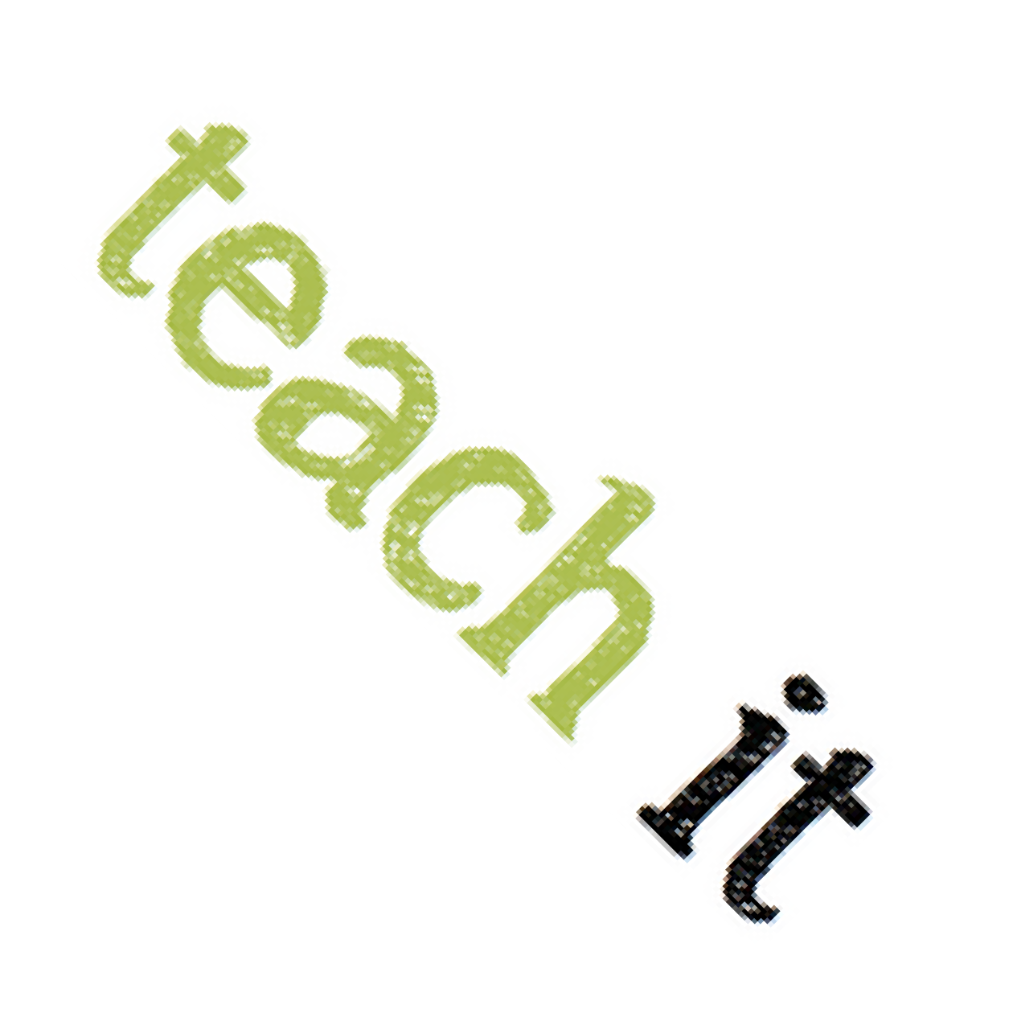
- See page 36 for an activity for high school students about Lemuel Haynes, widely considered to be the first Black man in America to be ordained by a Protestant church.
- Learn about the role the Amistad incident played in the abolitionist movement in the United States.

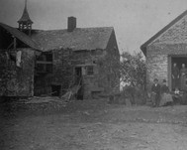
People

- Mary Townsend Seymour, activist
- Toney, Black Loyalist refugee
- Yung Wing, educational pioneer
New-Gate Prison Yard

Places

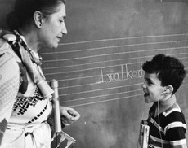
- Mary & Eliza Freeman Center, Bridgeport
- Foreign Mission School, Cornwall
- Old New-Gate Prison and Viets Tavern, East Granby

Events
American School
for the Deaf

- Amistad Trial - 1839
- Opening of the American School for the Deaf - April 15, 1917
- Passing of the Gay-Rights Bill - May 1, 1991

EDUCATIONAL RESOURCES
RESOURCES

Teach It provides inquiry-based activities that reinforce the principles found in the state social studies standards to help Connecticut’s teachers bring Connecticut history into the classroom.

ConnecticutHistory.org is a state public history resource that provides engaging, well-researched stories about Connecticut history that link to reliable primary and interpretive resources.

The Connecticut Council for the Social Studies will be hosting conferences for students and teachers focused on the themes of the 250th.

Teachers and students are encouraged to participate in Connecticut History Day and develop projects related to the 250th and the themes for this commemoration.

Connecticut’s Kid Governor immerses 5th graders in a real election for the CT Kid Governor, a fellow 5th grader who will represent them during a one-year term of active leadership. The program teaches about state government, voting, elections, and civic participation.

The Museum of the American Revolution has put together a Summer Reading List for young readers, covering books appropriate for ages 7-14.


ONLINE RESOURCES

Connecticut Archives Online (CAO) brings together information about primary source collections from over 50 institutions in CT into one site. CAO can connect you with unique archival material and where you can go to find it.

Connecticut Collections (CTCo) makes resources from over 50 museums and archives throughout the state accessible in one place. CTCo is a resource for teachers, students and researchers to learn discover collections, find local history, and learn about art.

The Connecticut Digital Archive (CTDA) is a digital repository of over 3+ million digital objects. CTDA facilitates access to a wide range of resources from over 100 Connecticut organizations.

Connecticut Explored is the nonprofit magazine of Connecticut history. Anyone with an interest in the untold stories of Connecticut’s past can satisfy their curiosity with each issue of Connecticut Explored. The magazine offers a variety and range of stories that connect our past to our present and future.





CT Humanities (CTH) is the non-profit organization recognized by the State of Connecticut to coordinate and lead the plans for commemorative, educational, and civics-based initiatives leading up to and during 2026.CTH will serve as the administrative agent and act as the nonprofit fiduciary on behalf of any activities undertaken by the America 250 | CT Commission.

As the principal grantmaking organization for history, cultural, and civics organizations in Connecticut, CTH will bring together communities and cultural resources throughout our state and lead the sector in developing a meaningful commemoration.

ABOUT THE COMMISSION

In order to recognize this moment in our history, Governor Ned Lamont established the America 250 | CT Commission with Executive Order 22-2.

Mission:

To plan and coordinate activities commemorating the 250th anniversary of the nation’s founding; and enhance tourism, economic development, historic education and preservation, and outdoor recreation within the state; and coordinate, engage, and liaise with the U.S. Semiquincentennial Commission, and other local, county, and state commissions, as well as private and public organizations and partners. The Commission will develop, encourage, and execute an inclusive celebration, commemoration, and observance of the 250th anniversary of the Declaration of Independence through civic, cultural, and historical education events and programming; and will promote the documentation, identification, and preservation of cultural and historic resources, including archives, buildings, landscapes, objects, and sites related to the semiquincentennial period.

To learn more about the America 250 | CT Commission, including existing resources, upcoming meetings, and ways to get involved, visit CT250.org.






STAY
CONNECTED

info@CT250.org

www.CT250.org

