Sample: https://www.givelocalccf.org/organizations/bridgewaterlandtrust

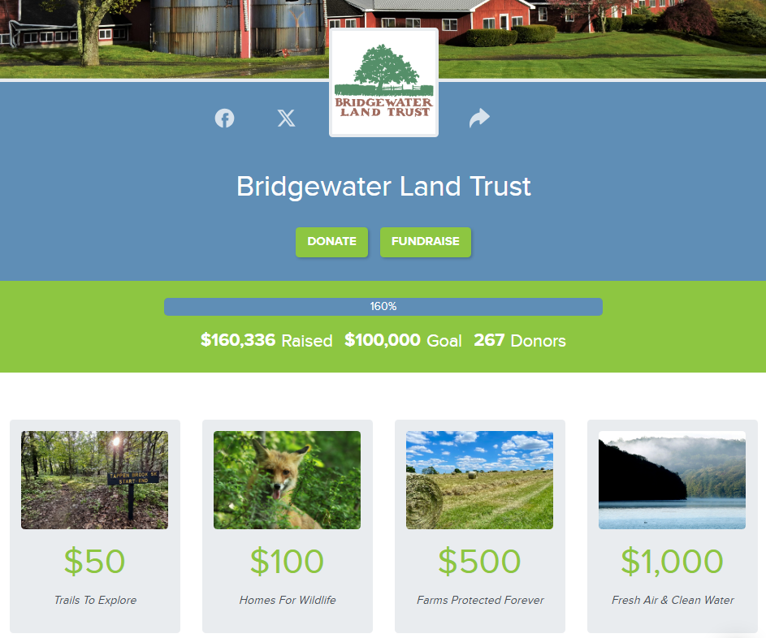
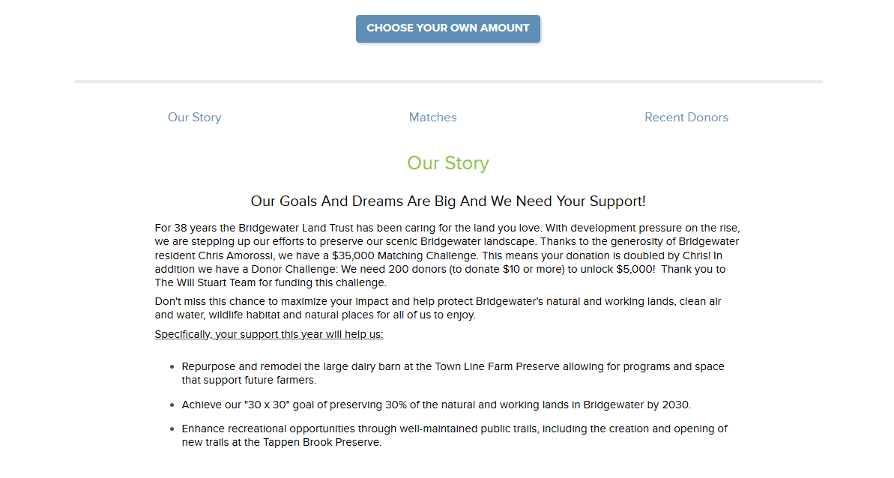
Your Giving Page

Logo: This can be an actual logo if you have one, or can be a simple image that represents your town (i.e. town hall, seal, etc). The recommended dimensions for your logo are 300x300px, and the max file size is 5MB. The image must be a JPG, JPEG, or PNG file type.

Cover Photo: The recommended dimensions for your cover photo are 1500x500px, and the max file size is 5MB. The image must be a JPG, JPEG, or PNG file type.

Fundraising Goal: Set a fundraising goal that is at the top end of what you feel is reasonably achievable in your community.

Giving Levels:
Amount | Description | Image
$X | Highlight the impact of that giving amount in 75 characters or less. | Images for Donation Levels should be 5MB max and a JPG, JPEG, or PNG file type. The dimensions can be flexible, as you can edit how the image is displayed when uploading it.

Our Story: Use this section to share a paragraph or two about your committee. You might include a mission and/or vision statement, information about who in town is working on this project, and a recap of any activities that you have participated in so far (i.e., Two Lights for Tomorrow or a program planned by your town). Also include an outline of plans or hopes for commemoration and what the money might be used for - even if you don’t have concrete plans yet, it’s helpful for donors to get an idea of what their money may go towards. Refer to our “Funding Use Ideas” document for inspiration if needed.
This section may include additional images and an embedded YouTube or Vimeo video if desired. Vimeo links must be in the following format: https://vimeo.com/123456.

Matches: See form.

“Thank You” Message:
- 'Thank You' Video: Must be a YouTube or Vimeo link. Vimeo links must be in the following format: https://vimeo.com/123456. You can add a video OR a photo, not both. If you add links for both, only the video will be sent in the 'Thank You' e-mail your donors will receive.
- 'Thank You' Photo: The recommended dimensions for your 'Thank You' photo are 800x600px, and the max file size is 5MB. The image must be a JPG, JPEG, or PNG file type.

